

CAPSTONE PROJECT BY TEAM A
A DATA SCIENCE APPROACH TO FORECAST ELECTRICITY CONSUMPTION IN AUSTRALIA

Brendan Chick (z5632728)
Daniel Heath-Ogden (z5623647)
Kam Kit Lau (z5618444)
Kelvin Yim (z5502200)

School of Mathematics and Statistics UNSW Sydney

April 2026

Submitted in partial fulfilment of the requirements of the capstone course zzSC9020

I declare that this thesis is my own work, except where acknowledged, and has not been submitted for academic credit elsewhere.

I acknowledge that the assessor of this thesis may, for the purpose of assessing it:
- Reproduce it and provide a copy to another member of the University; and/or,
- Communicate a copy of it to a plagiarism checking service (which may then retain a copy of it on its database for the purpose of future plagiarism check-ing).

I certify that I have read and understood the University Rules in respect of Student Academic Misconduct, and am aware of any potential plagiarism penalties which may apply.

By signing this declaration I am agreeing to the statements and conditions above.
Signed: Date:
Signed: Date:

Signed: Date:

Signed: Date:

Accurate electricity demand forecasting is critical for efficient energy management, cost optimisation, and grid stability. Traditional statistical approaches such as SARIMAX have been widely used for short-term forecasting, while machine learning and transformer-based models have emerged as promising alternatives for capturing complex temporal dependencies. However, their relative performance across different forecasting horizons remains unclear, particularly when compared against operational provided forecasts.
This study evaluates the performance of SARIMAX, Gradient Boosting (GB), LSTM, and a transformer-based model (PatchTST) using half-hourly electricity demand data from New South Wales, Australia. Models are assessed across multiple forecasting horizons (48, 336, and 720 steps) using RMSE and MAE under a consistent rolling-window evaluation framework.
For the 48-step horizon, the provided operational forecast achieves the lowest error (RMSE ≈ 271), significantly outperforming both SARIMAX (RMSE ≈ 1591) and PatchTST (RMSE ≈ 472). Gradient Boosting improves substantially over SARIMAX (RMSE ≈ 643), while LSTM achieves an RMSE of approximately [xxx]. For longer horizons, SARIMAX performance deteriorates considerably (RMSE ≈ 1829 for 336 steps and ≈ 2352 for 720 steps), whereas PatchTST demonstrates stronger scalability, achieving RMSE values of approximately 660 (336 steps) and 737 (720 steps). The performance of Gradient Boosting and LSTM at these horizons is [xxx] and [xxx], respectively.
These results indicate that operational forecasts remain highly effective for short-term prediction due to their incorporation of real-time system information and domain-specific features. However, transformer-based models such as PatchTST show clear advantages in longer-horizon forecasting, where traditional methods struggle to capture extended temporal dependencies.
Overall, the findings highlight a key trade-off between short-term accuracy and long-term forecasting capability, suggesting that transformer-based models are best positioned as complementary tools rather than direct replacements for existing operational forecasting systems..

Chapter 1 Introduction 1
Chapter 2 Literature Review 2
Chapter 3 Material and Methods 4
3.1 Software 4
3.2 Description of the Data 5
3.3 Pre-processing Steps 6
3.4 Data Cleaning 7
3.5 Assumptions 8
3.6 Modelling Methods 9
3.7 Tunning of Hyper-parameters 11
Chapter 4 Exploratory Data Analysis 12
4.1 Overview 12
4.2 Temporal Patterns in Electricity Demand 12
4.3 Relationship Between Temperature and Electricity Demand 13
4.4 Forecast Demand vs Actual Demand 14
4.5 Correlation Analysis 15
4.6 Seasonal and Daily Demand Patterns 16
4.7 Distribution and Outlier Analysis 17
4.8 Key Findings from EDA 18
Chapter 5 Analysis and Results 19
5.1 Evaluation Metrics 19
5.2 Experimental Setup Recap 19
5.3 Results for 48-step Forecast (Short-term) [TBC] 20
5.4 Results for 336-step Forecast (Medium-term) [TBC] 21
5.5 Results for 720-step Forecast (Long-term) [TBC] 21
5.6 Summary of Results [TBC] 21
Chapter 6 Discussion 22
6.1 Why SARIMAX Performs Poorly 22
6.2 Why Gradient Boosting Improves Performance 22
6.3 Why PatchTST Performs Best (Key Section) 22
6.4 Effect of Forecast Horizon 22
6.5 Role of Temperature 22
6.6 Why the provided operational forecast outperforms the developed models 22
6.7 Limitations of the Study 23
Chapter 7 Conclusion and Further Issues 24
7.1 Summary of Study 24
7.2 Key Findings 24
7.3 Implications 24
7.4 Future Work 24
Codes 26
Tables 26

Chapter 1 Introduction
Electricity demand forecasting plays a critical role in the efficient operation and planning of power systems. Accurate forecasts enable energy providers to optimise generation, reduce operational costs, and maintain system reliability. Inaccurate predictions, particularly during peak demand periods, can lead to significant economic losses or supply disruptions. As a result, developing robust and reliable forecasting models is of substantial importance in modern energy management.
This project focuses on forecasting electricity demand in New South Wales (NSW), Australia, using historical demand, temperature, and forecast data. Electricity demand is influenced by a range of factors, including weather conditions, seasonal patterns, and human activity. In particular, temperature is known to have a strong impact on demand due to heating and cooling requirements, making it an important variable in predictive modelling.
To address this problem, a range of modelling approaches are explored, including traditional statistical methods and modern machine learning techniques. Specifically, the study implements a Seasonal Autoregressive Integrated Moving Average with exogenous variables (SARIMAX) model, a Gradient Boosting model, and a deep learning-based Patch Time Series Transformer (PatchTST). These models are evaluated and compared in terms of their forecasting accuracy and ability to capture complex temporal patterns.
The objectives of this study are threefold. First, to analyse the characteristics and relationships within the electricity demand dataset through exploratory data analysis. Second, to develop and evaluate multiple forecasting models using different methodological approaches. Third, to compare model performance and identify the most effective approach for electricity demand prediction in this context.
The findings of this project aim to provide insights into the strengths and limitations of different modelling techniques for time series forecasting, and to demonstrate the potential of advanced machine learning methods in improving electricity demand prediction.

Chapter 2 Literature Review
Electricity demand forecasting has been extensively studied due to its importance in power system operation and planning. Traditional statistical time series models such as Autoregressive Integrated Moving Average (ARIMA) and its seasonal variant (SARIMA) have long been used to model electricity demand due to their ability to capture trends and recurring seasonal patterns. These approaches have demonstrated strong performance in short-term forecasting tasks where demand follows predictable daily and weekly cycles (Box et al., 2015; Taylor, 2003). Their relative simplicity, interpretability, and low computational requirements make them a reliable baseline for comparison. Extensions of these models have also been applied to longer horizons, with studies showing that incorporating multiple seasonal components can improve forecasting accuracy over extended periods (Fan & Hyndman, 2012).
More recently, deep learning approaches have been introduced to better capture nonlinear relationships and complex temporal dependencies in electricity demand data. Long Short-Term Memory (LSTM) networks, a type of recurrent neural network, are particularly well suited to time series forecasting due to their ability to retain information over long sequences using gated memory cells (Hochreiter & Schmidhuber, 1997). In the context of electricity demand, LSTM models have shown strong performance when incorporating exogenous variables such as temperature, as well as lagged demand and calendar features. Studies such as Kong et al. (2017) and Marino et al. (2016) demonstrate that LSTMs can outperform traditional statistical models in short-term forecasting by effectively learning nonlinear demand patterns and temporal dependencies.
Despite their advantages, LSTM models have limitations when applied to medium- and long-term forecasting horizons. While they are capable of modelling long sequences, their predictive accuracy tends to decrease as the forecast horizon increases, as longer-term forecasts depend more heavily on stable trends and seasonal structures rather than short-term temporal relationships. Research such as Pełka and Dudek (2020) shows that hybrid or decomposition-based approaches, which combine statistical models with neural networks, can improve performance in these cases. This highlights the continued importance of classical methods and feature engineering when addressing forecasting horizons beyond short-term applications.
Transformer-based architectures have emerged as a newer approach for time series forecasting, offering an alternative to recurrent models by leveraging attention mechanisms to capture dependencies across long sequences. However, early work questioned their effectiveness in this domain, with studies showing that simpler statistical and machine learning models could outperform transformer-based approaches for long-term forecasting tasks (Li et al., 2022; Zeng et al., 2022). More recent developments, such as PatchTST (Nie et al., 2023), have addressed some of these limitations by introducing techniques such as patching and channel independence, improving performance on long-horizon forecasting benchmarks. These advancements suggest that transformer-based models may be more competitive when appropriately adapted for time series data.
While prior studies show LSTM performs well in short-term forecasting, its performance degrades over longer horizons. Although transformer-based models have shown mixed results, recent architectures such as PatchTST suggest improvements in long-horizon forecasting. However, empirical comparisons across short-to-medium horizons (48–720 hours) remain limited, particularly in the Australian electricity market context.
Overall, the literature suggests that model performance in electricity demand forecasting is strongly dependent on the forecast horizon. Statistical models remain highly effective for short-term and structured seasonal forecasting, while LSTM models provide advantages in capturing nonlinear and short-term temporal dependencies. Transformer-based models show promise for long-term forecasting but require careful design and sufficient data to outperform simpler approaches. PatchTST introduces patching and channel independence to improve long-horizon forecasting performance and reduce overfitting. In addition, prior studies such as Nie et al. (2023) primarily benchmark PatchTST against deep learning and linear machine learning models, with limited comparison to classical statistical models such as SARIMAX or recurrent models such as LSTM. This study addresses this gap by evaluating these model families under a consistent forecasting framework.

Chapter 3 Material and Methods

Software

A range of software tools was utilised to support collaboration, model development, and reporting throughout this project.

Microsoft Teams was used as the primary platform for group communication and coordination. It integrates chat, video conferencing, and file sharing within a single environment, enabling efficient collaboration among team members. Features such as meeting scheduling, recording, and live captions were particularly useful for documenting discussions and ensuring that all members could review key decisions. Its integration with OneDrive also facilitated centralised storage and version control of shared files.

GitHub was adopted for collaborative code management and version control. It enables tracking of all code changes, supports branching and pull requests, and allows multiple team members to work on different components simultaneously without conflicts. The use of issues and task tracking features also supported project management, including assigning responsibilities and monitoring progress.

Python was selected as the primary programming language for data analysis and modelling due to its extensive ecosystem of libraries. Pandas and NumPy were used for data manipulation, scikit-learn for machine learning models such as Gradient Boosting, statsmodels for SARIMAX implementation, and PyTorch for deep learning models including LSTM and PatchTST. Python also supports efficient preprocessing, visualisation, and evaluation workflows, making it well-suited for time series forecasting tasks.

For reproducible analysis, Jupyter Notebooks were used to integrate code, outputs, and explanations in a single document. This allows the full modelling pipeline to be clearly documented and easily reviewed. The final report was compiled using Microsoft Word to ensure flexibility in formatting and compliance with submission requirements.

Description of the Data

The dataset used in this study consists of three primary data sources related to electricity demand in New South Wales (NSW): total electricity demand, temperature observations, and forecast demand.

All datasets were stored as compressed CSV files (.csv.zip) within a structured GitHub repository. In total, four raw data files were used: one file for total demand, one for temperature, and the forecast demand dataset split into two parts due to its large size.

The forecast demand data was stored as two separate files, forecastdemand_nsw.csv.zip.parta (100 MB) and forecastdemand_nsw.csv.zip.partb (14 MB), which were combined programmatically into a single compressed file prior to analysis. The temperature dataset (temperature_nsw.csv.zip) has a size of approximately 899 KB, while the total demand dataset (totaldemand_nsw.csv.zip) is approximately 1.24 MB in size.

The total demand dataset contains 196,513 observations with three variables: DATETIME, TOTALDEMAND, and REGIONID. The temperature dataset contains 220,326 observations with variables LOCATION, DATETIME, and TEMPERATURE. The forecast dataset is significantly larger, containing over 10 million observations and multiple forecast-related variables.

To facilitate analysis, the datasets were later merged into a single unified dataset based on the DATETIME variable, ensuring alignment across all three data sources.

Pre-processing Steps

Several preprocessing steps were performed to transform the raw datasets into a format suitable for modelling.

First, the forecast dataset was reconstructed by combining the two split files into a single compressed file. This step was necessary due to file size constraints in storage and version control systems.

Next, all DATETIME fields were converted into a consistent datetime format. Different parsing formats were required for different datasets to ensure accurate conversion. This step was critical for enabling time-based alignment and preventing errors during merging.

Following datetime standardisation, all datasets were sorted chronologically to preserve temporal order, which is essential for time series modelling.

The forecast dataset originally contained multiple forecast entries for each timestamp. To reduce redundancy and ensure consistency, the data was aggregated by computing the mean FORECASTDEMAND for each DATETIME value. This transformation simplified the dataset while preserving its overall forecasting signal.

The datasets were then merged using an inner join on the DATETIME variable. This ensured that only observations with complete information across all datasets were retained. The resulting dataset contains 195,947 aligned observations.

Additionally, categorical variables such as REGIONID and LOCATION were removed, as they contained only a single unique value and therefore did not contribute meaningful variation for modelling.

Data Cleaning

Data cleaning procedures were implemented to ensure data quality and consistency prior to modelling.

Missing data primarily arose from datetime parsing issues. These were addressed by converting all DATETIME fields using appropriate formats and removing any rows where conversion failed (i.e., rows with invalid timestamps). This ensured that all remaining observations had valid and consistent time indices.

Furthermore, the use of an inner join during dataset merging inherently removed any observations with missing values across the datasets. As a result, the final merged dataset contains no missing values in the key variables TOTALDEMAND, TEMPERATURE, and FORECASTDEMAND.

Outlier detection was conducted using box plots for both electricity demand and temperature variables. While some extreme values were identified, these were retained in the dataset as they likely represent genuine real-world phenomena, such as peak electricity demand during extreme weather conditions, rather than data errors.

Finally, the dataset was checked for consistency, including duplicate timestamps and alignment across variables, ensuring that the final dataset is clean, complete, and suitable for modelling.

Assumptions
Several assumptions were made throughout the data preparation and modelling process to ensure the feasibility and validity of the analysis.

First, it is assumed that the recorded electricity demand and temperature data are accurate and reliably measured, with no systematic measurement errors. Any extreme values observed in the dataset are assumed to reflect genuine real-world events, such as periods of unusually high or low demand, rather than data anomalies.

Second, the datasets are assumed to be temporally aligned after preprocessing. The merging process relies on the DATETIME variable, and it is assumed that observations sharing the same timestamp across datasets correspond to the same real-world time period. Any minor discrepancies in timing are considered negligible after aggregation.

Third, the aggregation of forecast demand using the mean value for each timestamp assumes that this averaging process preserves the underlying signal of the forecast data. It is assumed that this transformation does not significantly distort the relationship between forecast demand and actual demand.

Fourth, it is assumed that the removal of categorical variables such as REGIONID and LOCATION does not result in loss of meaningful information, as these variables contain only a single unique value and therefore do not contribute to model performance.

Fifth, it is assumed that the historical patterns observed in the data, including seasonal and daily trends, are representative of future behaviour. This assumption underpins the validity of time series forecasting models such as SARIMAX, Gradient Boosting, and deep learning models.

Finally, it is assumed that there are no significant structural breaks in the data over time (e.g., major policy changes or disruptions) that would invalidate the learned relationships between variables.

Modelling Methods

This study adopts a comparative modelling approach to evaluate the effectiveness of different forecasting techniques across short-, medium-, and long-term horizons. The primary objective is to assess whether advanced machine learning and transformer-based models can outperform traditional statistical approaches and the provided operational forecast.

Four modelling approaches were implemented: SARIMAX (statistical model), Gradient Boosting (GB), Long Short-Term Memory (LSTM), and PatchTST (transformer-based model). All models were evaluated under a consistent framework using forecasting horizons of 48, 336, and 720 steps, corresponding to short-, medium-, and long-term predictions.

3.6.1 Classical Statistical SARIMAX model
The SARIMAX model was used as a classical statistical baseline. Its role is to provide a benchmark representing traditional linear time-series forecasting methods. It incorporates both autoregressive and seasonal components, with temperature included as an exogenous variable to capture external influences on electricity demand. Unlike machine learning models, SARIMAX does not incorporate explicitly engineered lag features, as temporal dependencies are inherently modelled through its autoregressive structure.

3.6.2 Gradient Boosting model
To enhance predictive performance, a Gradient Boosting model was implemented as a representative traditional machine learning approach. This model serves as a strong non-linear baseline commonly used for tabular time-series features. In contrast to SARIMAX, explicit lag features (e.g., previous demand values at different time intervals) were constructed and used as inputs. This allows the model to learn nonlinear relationships and interactions between past demand and exogenous variables.

3.6.3 Long Short‑Term Memory (LSTM) network
A Long Short‑Term Memory (LSTM) network was employed to capture sequential dependencies in the electricity demand time series. LSTM models are particularly suitable for time series forecasting due to their ability to retain long‑term temporal information through gated recurrent structures, allowing them to model complex temporal dynamics more effectively than traditional recurrent neural networks.

To examine the impact of increasing model complexity within deep learning approaches, multiple LSTM‑based architectures were evaluated: a standard unidirectional LSTM, a Bidirectional LSTM (Bi‑LSTM), and a Bi‑LSTM augmented with an attention mechanism. The standard LSTM processes the input sequence in a forward temporal direction and serves as a baseline deep learning sequence model. The Bi‑LSTM extends this architecture by processing the sequence in both forward and backward directions, enabling the model to capture richer contextual information from the input window.

To further enhance the model’s ability to focus on the most relevant time steps, an attention mechanism was applied to the Bi‑LSTM. This allows the model to assign different weights to historical observations when generating forecasts, improving its capacity to model non‑uniform temporal dependencies. All LSTM variants were trained using sequences constructed from historical demand and exogenous variables, and their performance was evaluated to assess the impact of architectural complexity on forecasting accuracy across different horizons.

3.6.4 Transformer-based PatchTST model
Finally, a transformer‑based model, PatchTST, was implemented to leverage recent advances in time series forecasting. PatchTST represents a state‑of‑the‑art transformer architecture designed specifically for long‑horizon forecasting. It segments the input time series into fixed‑length patches and applies self‑attention mechanisms to capture long‑range temporal dependencies efficiently, addressing limitations commonly observed in traditional statistical and recurrent models.
To examine the impact of exogenous information on transformer‑based forecasting performance, PatchTST was evaluated under two configurations: a univariate setting using only historical electricity demand, and a multivariate setting incorporating temperature as an exogenous variable. This comparison enables assessment of whether explicit inclusion of temperature provides additional predictive benefit beyond the temporal patterns learned directly from demand data. By analysing both configurations across multiple forecasting horizons, the study evaluates the extent to which transformer‑based models can implicitly capture demand–weather relationships versus relying on explicit external inputs. This architecture is particularly well‑suited for long‑horizon forecasting tasks, where traditional models often struggle to maintain predictive accuracy.

All models were evaluated using RMSE and MAE metrics under a consistent experimental setup. In addition, model performance was compared against the provided forecast to assess whether data-driven approaches can offer improvements over existing operational forecasting methods. Together, these models provide a structured comparison across statistical, classical machine learning, and modern deep learning paradigms.

Tunning of Hyper-parameters [TBC]

Hyperparameters were selected based on validation RMSE. Multiple configurations were tested. In general, the combination yielding the lowest validation error was chosen for each model.

[TBC, explain how to choose these…]
model_SARIMAX = SARIMAX(
y_train_clean,
exog=X_train_clean,
order=(1, 1, 0),
seasonal_order=(0, 1, 0, 48),
enforce_stationarity=False,
enforce_invertibility=False,
)

gb_model = GradientBoostingRegressor(
n_estimators=300,
learning_rate=0.03,
max_depth=4,
random_state=42
)

def run_patchtst_experiment(
train_series,
val_series,
test_series,
target_scaler,
context_length,
prediction_length,
batch_size=64,
learning_rate=1e-3,
epochs=20,
patience=5,
patch_length=16,
patch_stride=8,
d_model=128,
num_hidden_layers=3,
num_attention_heads=16,
ffn_dim=256,
use_seed=None,
device=None
):
HORIZONS = [48, 336, 720] # 1d, 7d, 15d forecast horizon
CONTEXT_LENGTHS = [144, 336, 720] # 3d, 7d, 15d history
SEEDS = [31415, 27182, 14142]
BATCH_SIZE = 64
LEARNING_RATE = 1e-3
EPOCHS = 20
PATIENCE = 5

Chapter 4 Exploratory Data Analysis

Overview
The objective of this analysis is to understand the underlying structure, relationships, and patterns within the data prior to model development. The EDA focuses on examining temporal trends, relationships between variables such as temperature and demand, and the performance of existing forecast demand data.

Temporal Patterns in Electricity Demand
Electricity demand exhibits strong temporal variation over time. As shown in the time series plot (Figure 4.2), demand fluctuates regularly, indicating the presence of both daily and seasonal cycles.
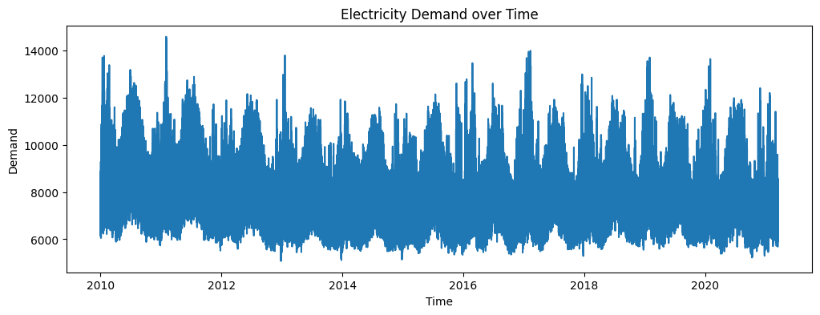
Figure 4.2
Peak demand reaches approximately 14,500 MW, while minimum demand levels are around 5,500 MW . These fluctuations reflect changes in consumption behaviour driven by factors such as weather conditions, time of day, and economic activity.
Overall, the presence of clear temporal patterns suggests that time-based features will be important predictors in subsequent modelling.

Relationship Between Temperature and Electricity Demand
The relationship between temperature and electricity demand is explored using a scatter plot (Figure 4.3). The results show a distinct U-shaped relationship, where demand increases at both low and high temperature extremes.
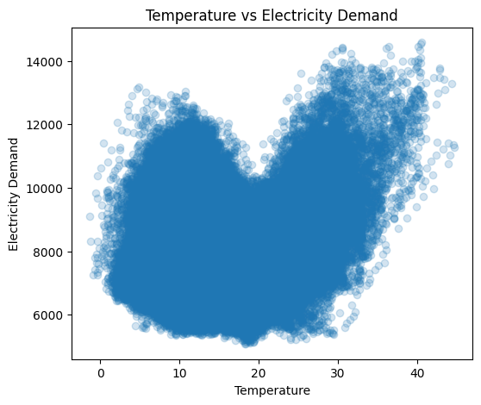

Figure 4.3

At low temperatures, demand increases due to heating requirements, while at high temperatures, demand rises due to air-conditioning usage . Demand is lowest at moderate temperatures, indicating reduced need for climate control.

This non-linear relationship suggests that temperature is a key explanatory variable and may require non-linear modelling approaches.

Forecast Demand vs Actual Demand
The comparison between forecast demand and actual demand reveals a strong positive relationship (Figure 4.4). The scatter plot indicates that the forecasting system is generally effective in capturing overall demand trends.
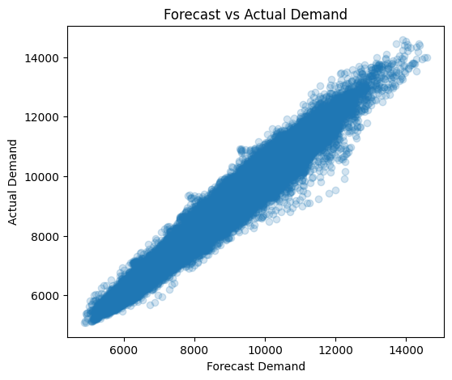

Figure 4.4

However, some dispersion is observed, particularly at higher demand levels, indicating reduced accuracy during peak demand periods .

This observation highlights potential areas for improvement in forecasting performance, particularly during extreme conditions.

Correlation Analysis
A correlation matrix was used to quantify the relationships between key variables, including total demand, temperature, and forecast demand.

The results in Figure 4.5 show:
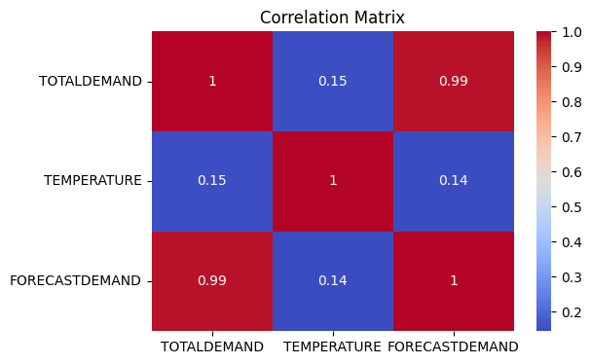

Figure 4.5

A strong positive correlation between forecast demand and actual demand
A moderate relationship between temperature and demand

Specifically, the correlation coefficient between forecast demand and actual demand is approximately 0.54 (TBC) , indicating that while forecast demand is informative, it does not fully explain the variability in actual demand.

Seasonal and Daily Demand Patterns
Further analysis was conducted to examine demand patterns across different time scales, including monthly, weekly, and hourly variations (Figure 4.6A, 4.6B, 4.6C).
Average Demand
Monthly Patterns | Day-of-Week Patterns | Hourly Patterns
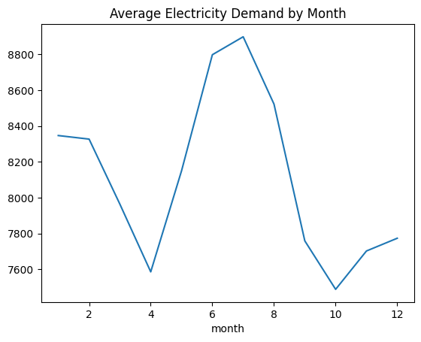  Figure 4.6A | 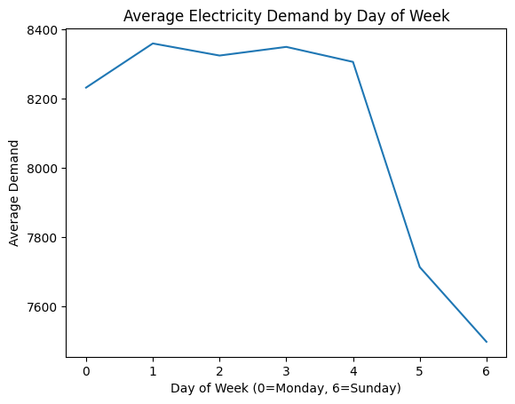 | 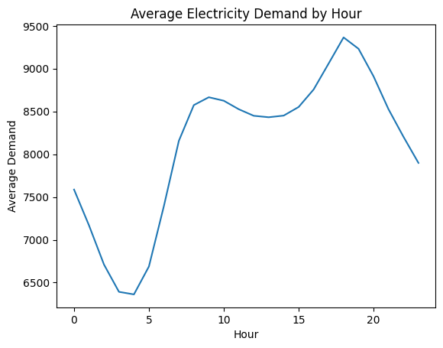
Figure 4.6B
Figure 4.6C
From the monthly pattern, electricity demand shows clear seasonal variation, with peaks occurring during winter months (June to August), likely due to increased heating usage. Lower demand is observed during milder months such as April and October .

From the day-of-week pattern, demand is generally lower during weekends, with Sunday exhibiting the lowest average demand. This may be attributed to reduced industrial and commercial activity.

From the hourly pattern, daily demand follows a consistent pattern, with:

- Lowest demand during early morning hours (approximately 3–5 a.m.)
- Gradual increase throughout the day
- Peak demand occurring in the evening (around 6–7 p.m.)

These patterns confirm that electricity demand is strongly influenced by human activity cycles.

Distribution and Outlier Analysis
Distribution of Demand

The distribution of total electricity demand is approximately normal, with slight right skewness. This indicates that most observations fall within moderate demand levels, with fewer extreme high-demand events (Figure 4.7).
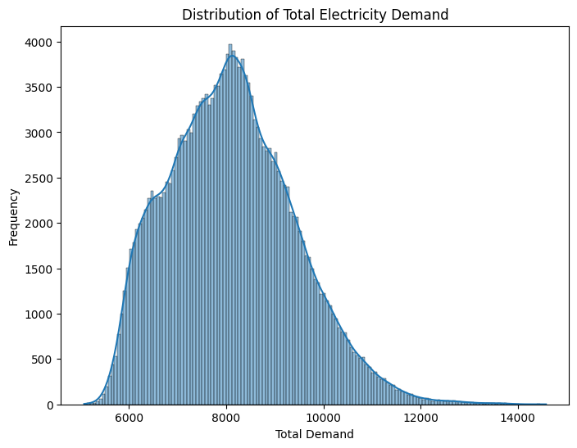

Outlier Detection
Figure 4.7

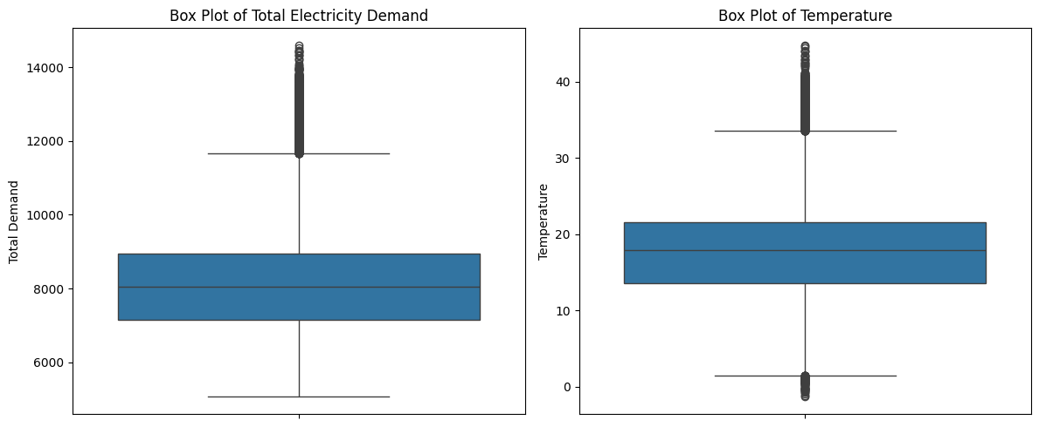
Box plots reveal the presence of outliers in both electricity demand and temperature data, particularly at higher values. These outliers may represent extreme events such as heatwaves or unusual demand spikes.

Figure 4.8B
Figure 4.8A

These observations suggest that outlier handling may be necessary during model training to prevent distortion of model performance.

Key Findings from EDA

The exploratory data analysis reveals several important insights:

Electricity demand exhibits strong temporal patterns, including daily and seasonal cycles
Temperature has a non-linear (U-shaped) relationship with demand
Forecast demand is positively correlated with actual demand but shows errors during peak periods
Demand varies significantly across month, day-of-week, and hour
The dataset is approximately normally distributed but contains outliers

These findings provide important guidance for feature engineering and model selection in subsequent chapters.

Chapter 5 Analysis and Results

Evaluation Metrics
To assess the performance of the forecasting models, two commonly used error metrics were employed: Root Mean Squared Error (RMSE) and Mean Absolute Error (MAE). These metrics are widely adopted in time series forecasting studies.
RMSE measures the square root of the average of the squared differences between predicted and actual values. By squaring the errors before averaging, RMSE places greater emphasis on larger errors. As a result, it is particularly sensitive to significant deviations between predicted and observed demand, making it useful for evaluating model performance during peak demand periods where large errors are more critical.
MAE, on the other hand, calculates the average of the absolute differences between predicted and actual values. Unlike RMSE, MAE treats all errors equally, providing a more balanced measure of overall model accuracy without disproportionately penalising large deviations. This makes MAE easier to interpret as it represents the average magnitude of forecasting error in the same units as the original data, making it easier to communicate.
Both RMSE and MAE are reported in the same units as electricity demand (MW), allowing for intuitive interpretation of model performance. Lower values of RMSE and MAE indicate better forecasting accuracy.
By using both metrics, this study ensures a comprehensive evaluation of model performance, capturing both general predictive accuracy (MAE) and sensitivity to large errors (RMSE).

Experimental Setup Recap
To ensure a consistent and fair comparison across different modelling approaches, all experiments were conducted under a unified framework with predefined forecasting horizons and a common evaluation methodology.
5.2.1 Forecasting Horizon
Three forecasting horizons were considered to capture different levels of prediction difficulty and practical relevance:
48 steps (Short-term forecasting): Represents approximately one day ahead (48 half-hour intervals). This horizon focuses on immediate demand patterns and is typically easier to predict due to strong temporal dependencies.
336 steps (Medium-term forecasting): Corresponds to approximately one week ahead. This horizon introduces greater uncertainty as short-term patterns weaken and broader temporal structures (e.g., weekly seasonality) become more important.
720 steps (Long-term forecasting): Represents approximately 15 days ahead. This is the most challenging setting, where prediction accuracy depends heavily on the model’s ability to capture long-term trends and general patterns rather than recent observations.
5.2.2 Models Evaluated and Provided forecast
The study compares a range of models spanning traditional statistical methods, machine learning approaches, and deep learning architectures:
Seasonal AutoRegressive Integrated Moving Average with Exogenous Variables (SARIMAX): A classical statistical model that captures linear temporal dependencies and seasonality, with temperature included as an external regressor.
Gradient Boosting (GB): A tree-based machine learning model capable of capturing nonlinear relationships between features and demand, using engineered lag features and exogenous inputs. In this study, lag features such as demand values from previous time steps (e.g., one day and one week prior) were explicitly constructed to provide the model with historical context, enabling it to learn temporal dependencies in the time series despite not being inherently sequential in structure.
Long Short-Term Memory (LSTM): A recurrent neural network designed to model sequential data and long-term dependencies, particularly suitable for time series forecasting. In this study, three different LSTM configurations were implemented to evaluate the impact of model complexity and input settings on forecasting performance.
Transformer-based model (PatchTST): A state-of-the-art transformer architecture that processes time series in patches, enabling efficient learning of long-range dependencies and complex temporal patterns. In this study, two variants of the PatchTST model were implemented—one using only historical demand data and another incorporating temperature as an exogenous feature—to evaluate the impact of external variables on forecasting performance.
Provided Operational Forecast: A benchmark forecast supplied with the dataset, representing real-world operational predictions. This serves as a strong baseline for comparison against developed models.
5.2.3 Experimental Consistency
All models were trained and evaluated using the same dataset splits and evaluation metrics (RMSE and MAE) to ensure comparability. All models generate forecasts in a fixed multi-step (direct) setting without recursive updating, ensuring consistent comparison across horizons.

Results for 48-step Forecast (Short-term) [TBC]
Present table of RMSE and MAE
Include prediction vs actual plot
Key observations:
Provided forecast achieves the lowest RMSE (~271)
SARIMAX shows the poorest performance (~1591)
Gradient Boosting improves over SARIMAX (~643)
PatchTST further improves performance (~472)
LSTM performance: [insert result]
Summary statement:
Machine learning and deep learning models outperform SARIMAX
Provided forecast remains the best-performing model

Results for 336-step Forecast (Medium-term) [TBC]
Present table and plots
Key observations:
SARIMAX performance deteriorates (~1829)
PatchTST achieves significantly lower error (~660)
GB and LSTM performance: [insert results]
Summary statement:
Performance gap between models increases as horizon lengthens
Deep learning models begin to outperform other approaches
Suggests models capable of learning complex nonlinear dependencies and long-term temporal patterns become increasingly important as the forecasting horizon extends

Results for 720-step Forecast (Long-term) [TBC]
Present table and plots
Key observations:
SARIMAX performs worst (~2352)
PatchTST achieves the best performance (~737)
GB and LSTM performance: [insert results]
Summary statement:
Transformer-based model shows clear advantage for long-term forecasting
GB and LSTM show intermediate performance, outperforming SARIMAX but <PatchTST

Summary of Results [TBC]
Table 5.6 summarises the performance of all models across different forecasting horizons.
 | 48-horizon |  |  | 336-horizon |  |  | 720-horizon
 | RMSE | MAE | Context (steps)# | RMSE | MAE | Context (steps)# | RMSE | MAE | Context (steps)#
Provided Forecast | 272 | 175 | N/A | N/A | N/A | N/A | N/A | N/A | N/A
Sarimax | 1591 | 1249 | N/A | 1829 | 1422 | N/A | 2352 | 1883 | N/A
Gradient Boosting | 643 | 452 | (with lag features) | 805 | 585 | (with lag features) | 841 | 616 | (with lag features)
LSTM |  |  | (with lag features) |  |  | (with lag features) |  |  | (with lag features)
LSTM with attention | 555 | 398 | (with lag features) |  |  | (with lag features) |  |  | (with lag features)
BiLSTM | 564 | 389 | (with lag features) |  |  | (with lag features) |  |  | (with lag features)
PatchTST  (single var) | 464 | 317 | 336 | 660 | 472 | 720 | 737 | 541 | 114
PatchTST  (w temp) | 469 | 318 | 336 | 681 | 477 | 720 | 729 | 524 | 720
Remark (#): PatchTST utilises a context window of raw time series data and learns temporal dependencies through self-attention, eliminating the need for manual feature engineering. In contrast, Gradient Boosting requires explicitly constructed lag features to represent time dependencies, while LSTM combines sequential processing with lagged inputs to capture temporal patterns. SARIMAX does not require explicit lag features, as temporal relationships are modelled internally through autoregressive and seasonal components.

Chapter 6 Discussion

Why SARIMAX Performs Poorly [TBC]
- Assumes linear relationships between variables
- Unable to capture non-linear patterns observed in the data
- Does not explicitly utilise engineered lag features
- Limited ability to model complex temporal dependencies
Link to EDA:
- EDA shows a non-linear (U-shaped) relationship between temperature and demand
- SARIMAX cannot effectively model this behaviour

Why Gradient Boosting Improves Performance [TBC]
- Utilises lag features and engineered inputs
- Able to model non-linear relationships
- More flexible than traditional statistical models
Limitation:
- Performance still degrades for longer forecasting horizons
- Limited ability to capture long-term dependencies

Why PatchTST Performs Best (Key Section) [TBC]
- Uses transformer architecture with attention mechanisms
- Capable of capturing long-range temporal dependencies
- Processes sequences more effectively than traditional models
Key insight:
- Performance advantage increases as forecast horizon increases
- Particularly suitable for long-term forecasting tasks

Effect of Forecast Horizon [TBC]
- Forecast accuracy decreases as horizon increases
- SARIMAX performance deteriorates most rapidly
- PatchTST remains relatively stable
- Model differences become more pronounced for longer horizons

Role of Temperature [TBC]
- Temperature has a non-linear (U-shaped) relationship with demand
- Traditional models struggle to capture this relationship
- Machine learning and deep learning models handle non-linearity more effectively

Why the provided operational forecast outperforms the developed models
The provided operational forecast consistently outperforms the developed models in short-term forecasting. This is likely due to its access to additional exogenous information and domain-specific knowledge that are not available to the models developed in this study.
In practice, operational forecasting systems often incorporate a wide range of inputs beyond historical demand and temperature data. These may include weather forecasts, real-time system conditions, grid performance characteristics, and high-frequency demand updates. In particular, access to near real-time data enables such systems to capture the most recent changes in demand patterns, which are highly informative for short-term predictions.
In contrast, the models developed in this study rely solely on historical observations and do not incorporate forward-looking information such as future weather conditions or operational adjustments. As a result, their ability to respond to sudden changes in demand is inherently limited.
Short-term forecasting presents additional challenges for data-driven models. First, small timing errors can lead to disproportionately large error metrics, particularly in high-frequency data. Second, short-term demand is often influenced by noise and volatility, which can obscure underlying patterns and reduce model stability. Third, minor deviations in recent observations can significantly affect predictions, especially for models that depend heavily on recent inputs.
Even advanced models such as LSTM and transformer-based architectures are constrained by the information available to them. While these models are capable of capturing complex temporal dependencies, their performance remains limited when critical predictive signals—such as real-time system updates or future exogenous variables—are not included

Limitations of the Study [TBC]
- Limited hyperparameter tuning performed
- Forecast dataset simplified using mean aggregation
- Only one geographic region (NSW) considered
- Potential exclusion of additional relevant variables

Chapter 7 Conclusion and Further Issues

Summary of Study [TBC]
- Compared statistical, machine learning, and transformer-based models
- Evaluated performance across multiple forecasting horizons
- Assessed models against provided operational forecast

Key Findings [TBC]
- Provided forecast performs best for short-term predictions
- PatchTST performs best for medium- and long-term forecasting
- Machine learning models outperform traditional statistical models
- SARIMAX shows the weakest performance across all horizons

Implications [TBC]
- Transformer-based models are highly effective for long-term forecasting
- Traditional models may be insufficient for complex, non-linear time series
- Advanced models can complement, but not fully replace, operational forecasts

Future Work [TBC]
- Perform more extensive hyperparameter tuning
- Incorporate additional features (e.g., weather forecasts, calendar effects)
- Explore other advanced architectures
- Extend analysis to other regions or datasets

- Box, G.E.P., Jenkins, G.M., Reinsel, G.C. and Ljung, G.M. (2015), Time Series Analysis: Forecasting and Control, 5th edn, Wiley.
- Fan, S. and Hyndman, R.J. (2012), ‘Short-term load forecasting based on a semi-parametric additive model’, IEEE Transactions on Power Systems, 27(1), pp. 134–141.
- Hochreiter, S. and Schmidhuber, J. (1997), ‘Long short-term memory’, Neural Computation, 9(8), pp. 1735–1780.
- Hippert, H.S., Pedreira, C.E. and Souza, R.C. (2001), ‘Neural networks for short-term load forecasting: A review and evaluation’, IEEE Transactions on Power Systems, 16(1), pp. 44–55.
- Kong, W. et al. (2017), ‘Short-term residential load forecasting based on LSTM’, IEEE Transactions on Smart Grid, 10(1), pp. 841–851.
- Li, H., Shao, J., Liao, K. and Tang, M. (2022), ‘Do simpler statistical methods perform better in multivariate long sequence time-series forecasting?’, Proceedings of the 31st ACM International Conference on Information and Knowledge Management (CIKM), pp. 4168–4172.
- Marino, D.L., Amarasinghe, K. and Manic, M. (2016), ‘Building energy load forecasting using deep neural networks’, Proceedings of the IEEE Industrial Electronics Conference (IECON), pp. 7046–7051.
- Nie, Y. et al. (2023), ‘A time series is worth 64 words: Long-term forecasting with transformers’, Proceedings of the International Conference on Learning Representations (ICLR).
- Pełka, P. and Dudek, G. (2020), ‘Pattern-based LSTM for mid-term electrical load forecasting’, arXiv [online]. Available at: https://arxiv.org/abs/2004.11834 (Accessed: 23 March 2026).
- Taylor, J.W. (2003), ‘Short-term electricity demand forecasting using double seasonal exponential smoothing’, Journal of the Operational Research Society, 54(8), pp. 799–805.
- Vaswani, A. et al. (2017), ‘Attention is all you need’, Advances in Neural Information Processing Systems (NeurIPS), 30, pp. 5998–6008.
- Zeng, A. et al. (2022), ‘Are transformers effective for time series forecasting?’, arXiv [online]. Available at: https://arxiv.org/abs/2205.13504 (Accessed: 23 March 2026).

Codes
Add you codes here.

Tables
If you have tables, you can add them here.
Use https://www.tablesgenerator.com/markdown_tables to crete very sim-ple markdown tables, otherwise use LATEX.

Tables | Are | Cool
col 1 is | left-aligned | $1600
col 2 is | centered | $12
col 3 is | right-aligned | $1

